How does the syntax of a CREATE VIEW statement look?
CREATE VIEW view_name AS
SELECT column1, column2, ...
FROM table_name
WHERE condition;

- create a view called EMPSALARY to display salary along with some basic sensitive data of employees from the HR database

CREATE VIEW EMPSALARY AS
SELECT EMP_ID, F_NAME, L_NAME, B_DATE, SEX, SALARY
FROM EMPLOYEES;

- Using SELECT, query the EMPSALARY view to retrieve all the records

SELECT * FROM EMPSALARY;

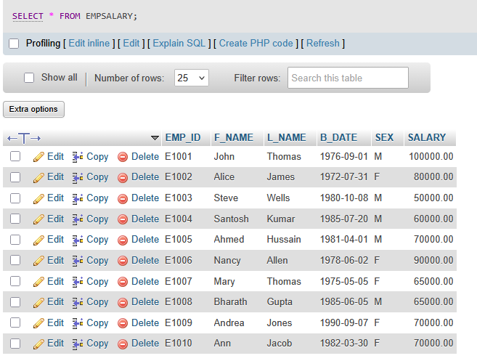

How does the syntax of a REPLACE VIEW statement look?
CREATE OR REPLACE VIEW view_name AS
SELECT column1, column2, ...
FROM table_name
WHERE condition;

- It now seems that the EMPSALARY view we created in exercise 1 doesn't contain enough salary information, such as max/min salary and the job title of the employees. Let's update the EMPSALARY view:

- combining two tables EMPLOYEES and JOBS so that we can display our desired information from the HR database.
- including the columns JOB_TITLE, MIN_SALARY, MAX_SALARY of the JOBS table as well as excluding the SALARY column of the EMPLOYEES table.

CREATE OR REPLACE VIEW EMPSALARY AS
SELECT EMP_ID, F_NAME, L_NAME, B_DATE, SEX, JOB_TITLE, MIN_SALARY, MAX_SALARY
FROM EMPLOYEES, JOBS
WHERE EMPLOYEES.JOB_ID = JOBS.JOB_IDENT;

- Using SELECT, query the updated EMPSALARY view to retrieve all the records.

SELECT * FROM EMPSALARY;

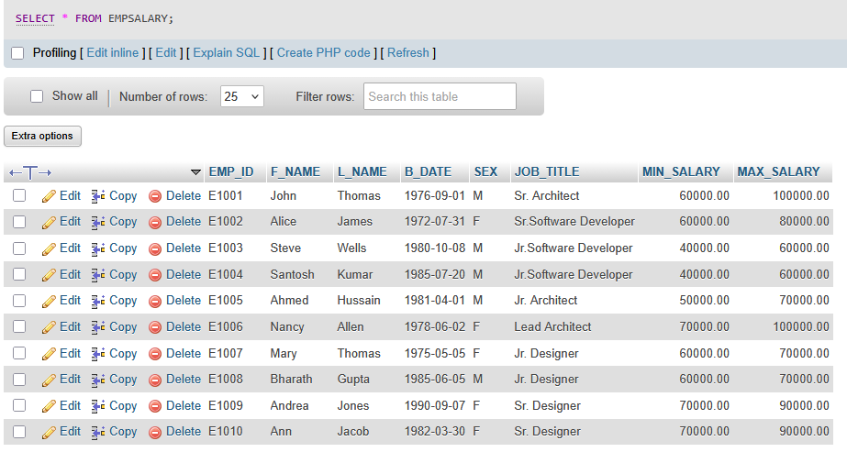

How does the syntax of a DROP VIEW statement look?
DROP VIEW view_name;

- Let's delete the created EMPSALARY view
DROP VIEW EMPSALARY;

- Using SELECT, you can verify whether the EMPSALARY view has been deleted or not
SELECT * FROM EMPSALARY;

